MIT – 200 ADVANCED DATABASE SYSTEMS

### Entities and Attributes

1. **Students**
   * student_id (Primary Key)
   * status (ENUM: 'Registered', 'Admitted', 'Assessed', 'Enrolled')
   * created_at (Timestamp)
   * updated_at (Timestamp
2. **Personal Information**
   * personal_info_id (Primary Key)
   * student_id (Foreign Key)
   * first_name (VARCHAR)
   * middle_name (VARCHAR)
   * suffix (VARCHAR)
   * gender (ENUM: 'Male', 'Female')
   * birthday (DATE)
   * age (INT)
   * birthplace (VARCHAR)
3. **Contact Information**
   * contact_info_id (Primary Key)
   * student_id (Foreign Key)
   * mobile_number (VARCHAR)
   * telephone (VARCHAR)
   * email (VARCHAR)
4. **Educational Information**
   * education_info_id (Primary Key)
   * student_id (Foreign Key)
   * academic_level (ENUM: 'Basic Education', 'Tertiary', 'Graduate School')
   * year_level (INT)
   * period (VARCHAR)
   * academic_year (VARCHAR)
   * course (VARCHAR)
5. **Family Information**
   * family_info_id (Primary Key)
   * student_id (Foreign Key)
   * mother_name (VARCHAR)
   * father_name (VARCHAR)
   * mother_contact_number (VARCHAR)
   * father_contact_number (VARCHAR)
   * mother_occupation (VARCHAR)
   * father_occupation (VARCHAR)

### Relationships

* **Students to Personal Information**: One-to-One
  + Each student has one personal information record, and each personal information record belongs to one student.
* **Students to Contact Information**: One-to-One
  + Each student has one contact information record, and each contact information record belongs to one student.
* **Students to Educational Information**: One-to-Many
  + Each student can have multiple educational information records, but each educational information record belongs to only one student.
* **Students to Family Information**: One-to-One
  + Each student has one family information record, and each family information record belongs to one student.

Logical ERD

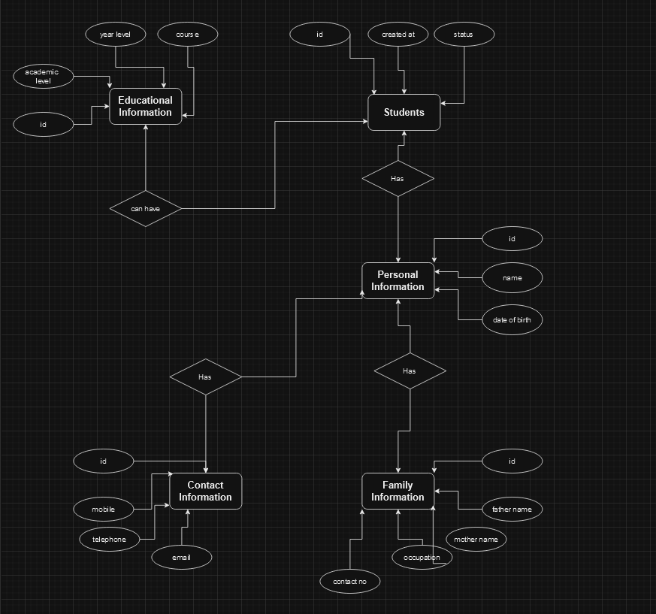

Physical ERD

